# **Ad Campaign Performance Report (March–April 2025)**

## **Overview**

This report presents a comprehensive analysis of an advertising dataset covering campaigns across five platforms and five ad types over a two-month period. The goal is to highlight user engagement patterns, platform and format performance, demographic behavior, and to provide actionable insights for future optimization.

## **About the Dataset**

The dataset consists of **200 ad interaction records** collected over a **2-month period (March–April 2025)**. It captures key advertising metrics and user demographics across **multiple digital platforms and cities in India**.

**📊 Data Overview:**

* **Platforms**: YouTube, Instagram, Google, LinkedIn, Facebook
* **Ad Types**: Banner, Carousel, Story, Popup, Video
* **Cities Covered**: Delhi, Hyderabad, Pune, Bengaluru, Mumbai, Chennai, Kolkata
* **User Demographics**:
  + **Age Range**: 18–60
  + **Gender**: Male, Female, Other (evenly distributed)
* **Key Metrics Captured**:
  + Impressions, Clicks, Conversions
  + Time Spent on Landing Page (in seconds)
  + Ad Spend (in INR)
  + Campaign ID and Date

The dataset is well-balanced across age, gender, platforms, and ad types, providing a reliable base for exploratory and performance-based analysis.

## **Major Findings**

**Key Metrics**:

* **Total Clicks**: 571
* **Average User Age**: 40
* **Total Spend**: ₹3,000
* **Peak Engagement Day**: April 16 (highest clicks and conversions)
* **Time-Based Trend**: April had generally higher engagement than March.

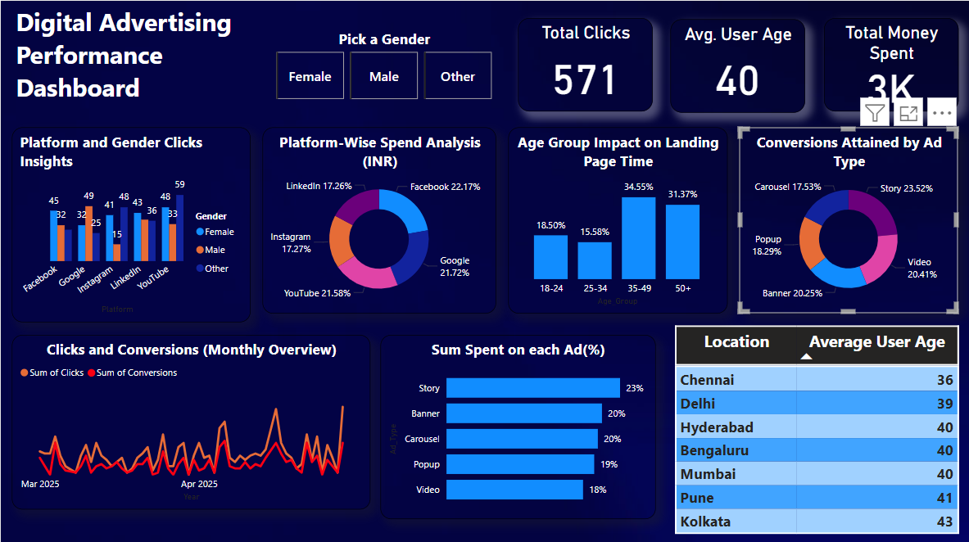

Figure 1: Campaign Metrics Dashboard Overview

**Platform Insights**:

* **Facebook** saw the **highest conversions** and **highest spend**.
* **YouTube** had the **lowest conversions**.
* **LinkedIn** received the **least ad spend**.
* Gender-wise clicks varied by platform: YouTube and Instagram saw more clicks from **‘Other’** gender users, while Facebook had high engagement from **females**.

**Ad Type Performance**:

* **Story ads** led in **conversions (26)** and also had the **highest spend**.
* **Carousel ads** had the **least conversions (16.29)**.
* **Video ads** had the **lowest spend**.

**Demographic Insights**:

* **Chennai** had the **youngest users (avg. age 36)**, and **Kolkata** the **oldest (avg. age 43)**.
* Users aged **35–49** spent the **most time on landing pages**, while **25–34** spent the **least**.

**Engagement by Gender & Platform** (Clicks):

* **YouTube**: Other – 59 (highest among platforms)
* **Facebook**: Female – 45
* **Instagram**: Other – 48
* **Google**: Male – 49
* **LinkedIn**: Female – 43

## **Key Takeaways**

* Facebook and Story ads are high-performing combinations.
* Targeting ‘Other’ gender users on YouTube and Instagram can boost engagement.
* Optimize campaigns in April based on strong conversion trends.
* Tailor landing pages better for 25–34 age group to increase interaction time.

## **Conclusion**

User engagement was balanced across demographics and platforms, with certain ad types and platforms driving significantly higher conversions. The story ad format and Facebook platform emerged as top performers. April witnessed more engagement, possibly due to campaign timing or relevance. Chennai attracted younger users, whereas Kolkata drew older ones—suggesting localized content targeting opportunities.

## **Actionable Recommendations**

* **Invest more in Story-format ads on Facebook**—they yield higher conversions and justify higher spend.
* **Reassess YouTube strategy**—conversions are low despite balanced clicks.
* **Explore gender-specific creatives** on YouTube and Instagram for ‘Other’ gender, where clicks are high.
* **Improve landing page content** for 25–34 age group to increase time spent.
* **Capitalize on April performance** by aligning high-impact campaigns during this month.